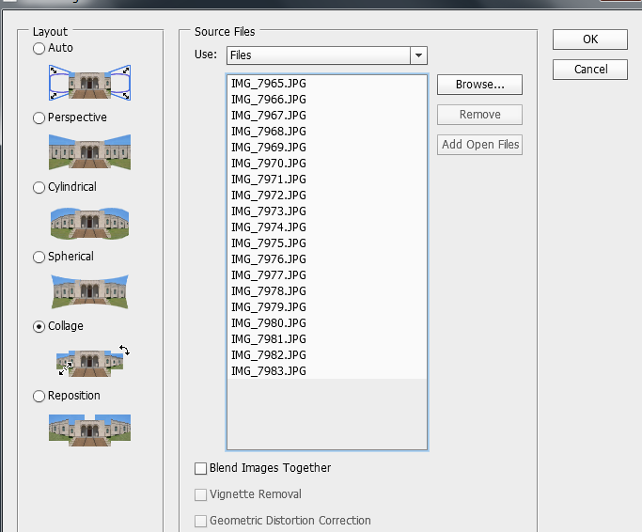
Photoshop instructions for Joiners
Open Photoshop- File-Automate-Photomerge
Select Collage from the layout options- untick Blend Images Together
Browse – find the photos you have taken and select them.
Click OK – the programme will then add each photo as a layer and then merge them together. This will take a couple of minutes.
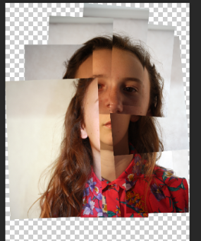
To rearrange any stray parts of the collage you can click on each layer and move parts of the photo using the move tool – top on the left hand menu.
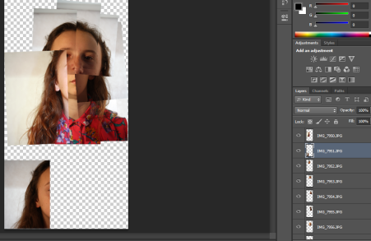

SCREEN CLIP HERE TO SHOW THE HALF WAY STAGE
Click on each layer and hid it with the eye symbol. You will be able to see if you need that layer.
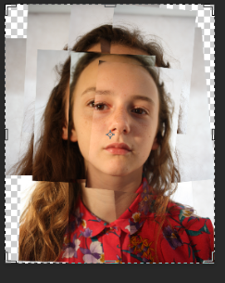
You can also rearrange the layers by clicking and dragging the layers up or down so they appear behind or in front of the rest of the layers.
Crop the image using the crop tool.

To make the background black- create a new layer using the new layer symbol below the layers.
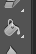
Draw round the rectangle with the rectangle tool.
Fill this with black using the paint bucket fill tool.
Move this layer to the bottom by clicking and dragging it.
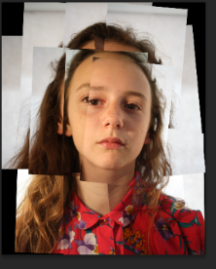
File- save as – select JPEG- save in you Large Media Filestore.

